ASSIGNMENT 14

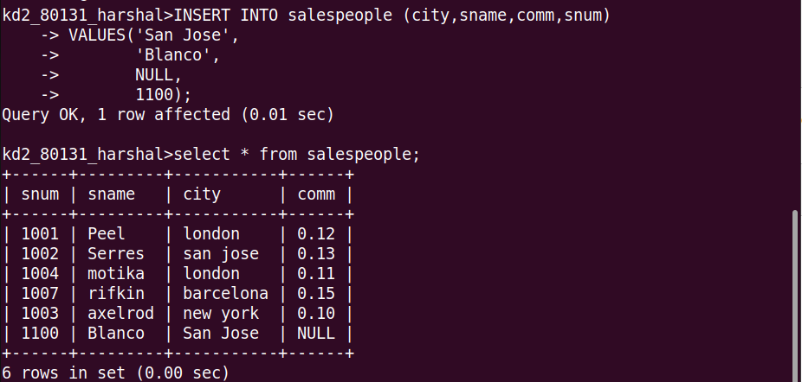
Que 1. Write a command that puts the follwing values, in their given order, into the salespeople table:city-san jose, name-blanco, comm-null, cnum-1100.

Que 2. Write a command that removes all orders from customer clemens from the orders table.

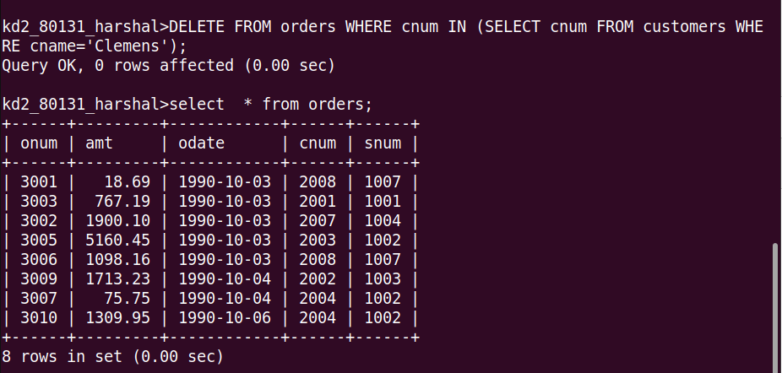
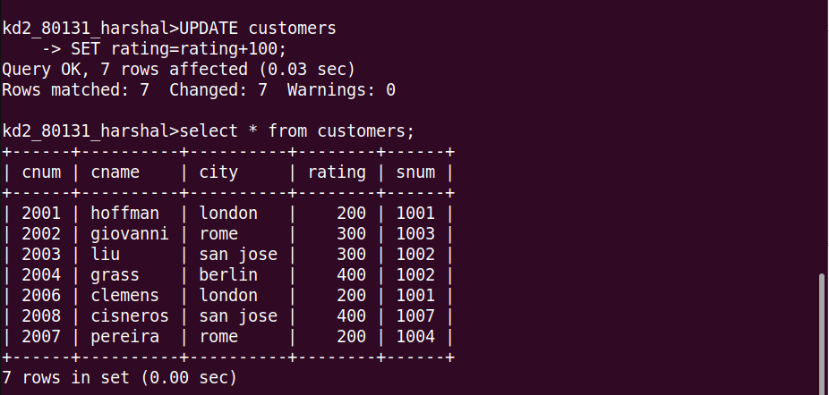
Que 3.Write a command that increases the rating of all customers in rome by 100.

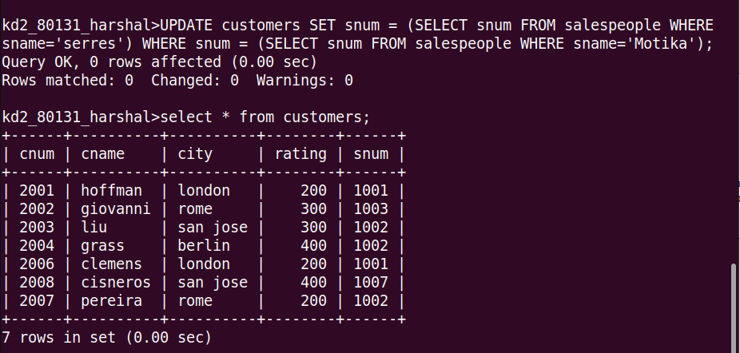
Que 4. salesperson serres has left the company. Assign her customers to motika.

